Viscous Damping Coefficient of a moving object
BY
THU TA ZAW

Measure the viscous damping coefficient of something moving.
Conduct a mini-experiment at the lowest possible cost.
Verify that you actually measured the viscous damping, not friction.
Note: Please show not only the experimental results, but also the idea (how to measure), measurement theory, theoretical resolution, accuracy, cost, evaluation/discussion etc.

In this assignment, I tried to measure the viscous damping coefficient c, of a stack of coin moving vertically in water.
Five one-yen coins were stacked together with tape, which behaved like one rigid cylinder. The 1-L plastic container with transparent side was filled with water. A rule was attached to the side of the container to provide a scale. A smartphone camera with 60 fps was used to record the falling object.
The weight and size of the coins were obtained from the official published documents and used them as a reference.
The stack of coins is assumed as a rigid body moving straight down.

Forces acting on the coins stacked
(free body diagram) coin photo

Gravity: $F_{g}=mg$
Buoyancy: $F_{b}=ρ_{f}Vg$ (upward)
Viscous Drag: $F_{d}=-cv$ (upward, proportional to velocity)

$ρ_{f}$ = water density
V = volume of coin stack
M = mass of coin stac
V = downward velocity.

Equation of motion:
$$m\frac{dv}{dt}=F_{g}- F_{b}-cv=mg- ρ_{f}Vg -cv$$

Effective weight:
$$W_{eff}=\left(m-ρ_{f}V\right)g$$
Then:

$$m\frac{dv}{dt}=W_{eff}-cv$$

This is a first-order linear ODE. Solve with $v\left(0\right)=0$:
$v\left(t\right)=v_{t} (1-e^{\frac{-t}{τ}}$)

where:
Terminal velocity:
$$v_{t}=\frac{W_{eff}}{c}$$
Time constant:
$$τ=\frac{m}{c}$$

So,
$$c=\frac{W_{eff}}{v_{t}}$$

Name | Value
Weight | 1.0 g
Diameter | 20.0 mm
Thickness | 1.2 mm
Density | 2.7 g/cm
Table. 1-yen coin’s data

From the experiment:
The coin stack travel 20.5 cm in 1.1s

Distance: y = 0.205 m
Time: t = 1.1 s
I assumed the velocity that calculated from the experiment as an average velocity.
$$v_{avg}=\frac{y}{t}= \frac{0.205}{1.1}=0.186 ms^{-1}$$

I will assume that the coin stack quickly reaches terminal speed and then moves almost at $v_{t}$,

$v_{t}≈ 0.186 ms^{-1}$

Mass: m = 0.005 kg
Volume: V = 1.88 x ${10}^{-6}$ $m^{3}$
Water density: $ρ_{f}$ = 1000 kg$m^{-3}$
Gravity: g = 9.81 m$s^{-2}$

Buoyant mass:
$$m_{water}= ρ_{f}V=1.88 x {10}^{-3}kg$$
Effective mass:
$$m_{eff}=m-m_{water}=0.00312 kg$$
Effective weight:
$$W_{eff}=m_{eff}g=0.00312 x 9.81≈ 0.0306 N$$

$c=\frac{W_{eff}}{v_{t}}≈ \frac{0.0306}{0.186}≈0.164Nm^{-1}$

$$c≈0.164 Nm^{-1}$$
$$τ=\frac{m}{c} ≈ \frac{0.005}{0.164}≈ 0.030 s$$

$$τ≈ 0.030 s$$
$$3τ≈ 0.090 s$$

By analyzing the result, the coin stack will already arrive >95% of its terminal speed within $\sim 0.1 s$.
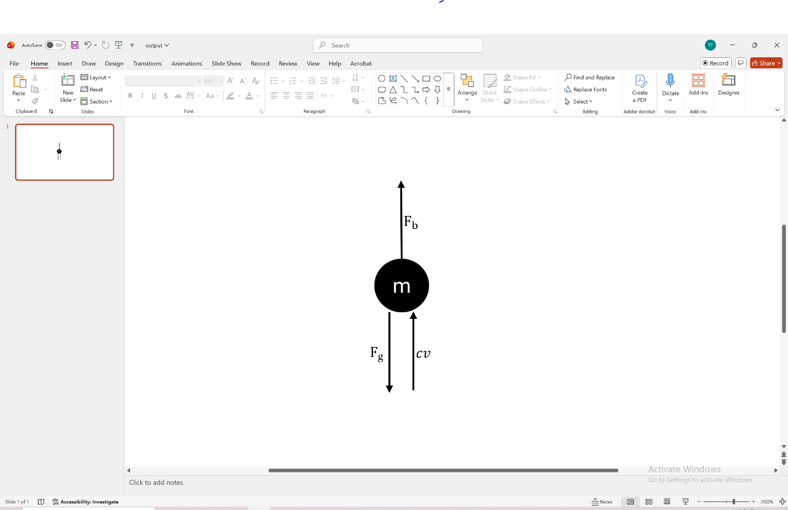

THU TA ZAW
2415121095

